**DIGITAL SIGNAL PROCESSING LAB**

**Lab sheet. No: 04**

**NAME: NIKHIL KILARI Roll. No: EE16B017**

**Question 1**

**Aim:**

To verify the linearity, time reversal, convolution-multiplication, time shifting, and parsevals theorem on the following sequences.

**Short Theory:**

Given,

x1[n] = [0.59 0.95 0.95 0.59 0.00 0.59 0.95 0.95 0.59 0.00]

x2[n] = [0.16 0.97 0.96 0.49 0.80 0.14 0.42 0.92 0.79 0.96]

We verify the above mentioned properties on the given signals.

**Key Commands:**

* fft()
* abs()
* angle()
* circshift()
* exp()
* sum()

**Result:**

**a)**

**b)**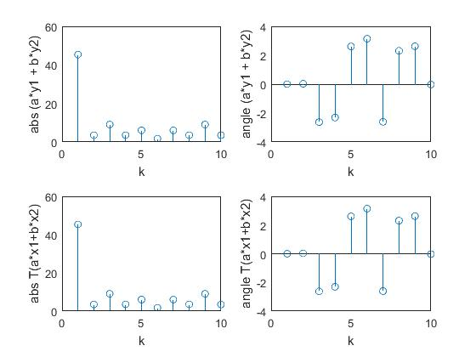

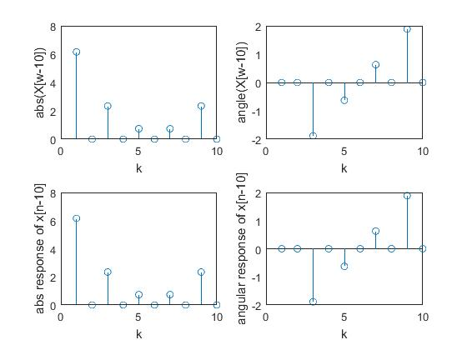

**c)**

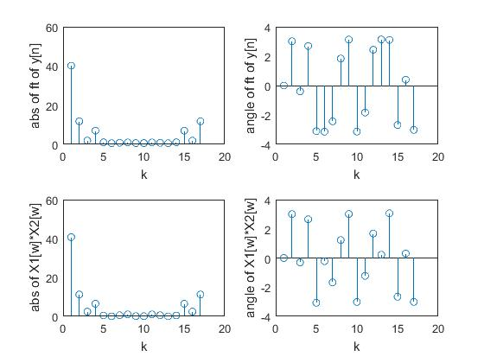

**d)**

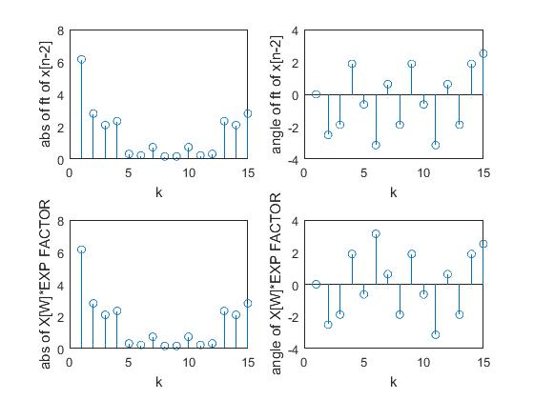

**Inferences/comments:**

Therefore we have successfully verified the mentioned properties using fft function in MATLAB.

**Question 2**

**Aim:**

To generate rectangular, sinusoidal, and Gaussian functions (mean zero, variance one), and find Fourier transform of the signals

**Short Theory:**

Here we need to generate the above mentioned signals using the necessary commands and plot their magnitude and Fourier transforms

**Key Commands:**

* rectangularPulse()
* fftshift()
* fft()
* gaussmf()

**Results:**

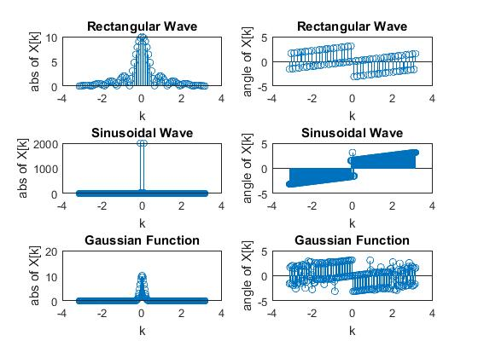

**Inferences/comments:**

We have successfully produced the frequency spectrum of the rectangular, sinusoidal and Gaussian functions.

**Question 3**

**Aim:**

To calculate the output signal when x[n] = sin(πn/4) and H(jw) = e-j2w/(1+0.5e-4jw).

**Short Theory:**

For the given H(jw) we find the numerator and denominator coefficients and calculate y[n] by using the filter function.

**Key Commands:**

* sin()
* filter()

**Result:**

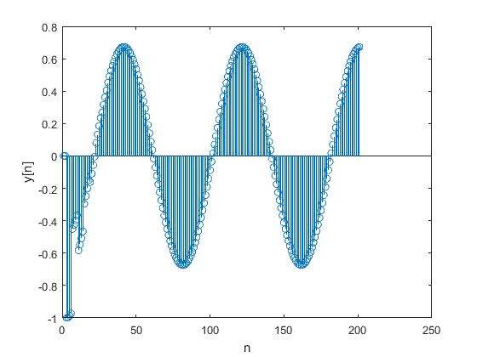

**Inferences/Comments:**

We have successfully found y[n] for the given x[n] and frequency response of the impulse response.

**Question 4**

**Aim:**

To identify whether the given signals are complex, real, even, odd etc based on their Fourier transform.

**Short Theory:**

We need to find the characteristics of

X1[n] = sin(200πn/8000)

X2[n] = cos(200πn/8000)

X3[n] = e0.02n

For -100<=n<=100

**Result:**

**a)**

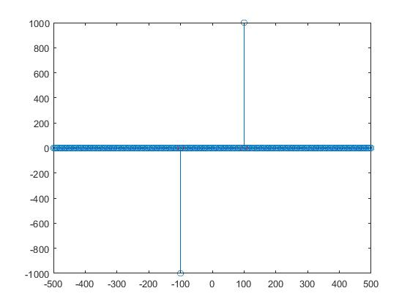

**b)**

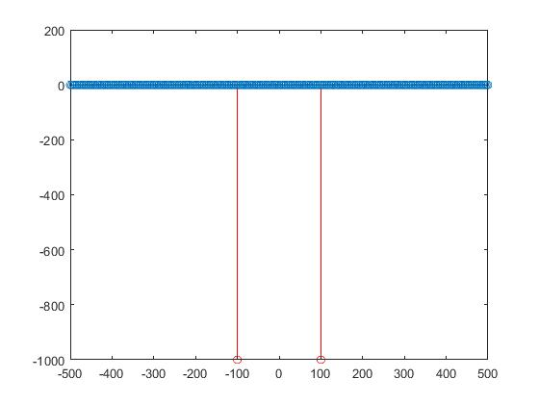

**c)**

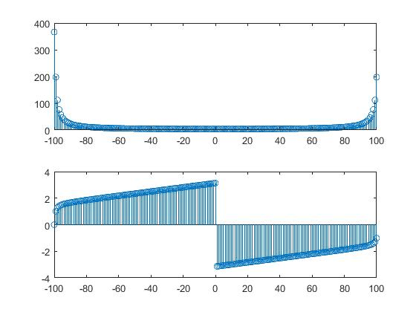

**Inferences/Comments:**

a)Real and Odd

b)Real and Even

c)Real and neither even nor odd

**Question 5**

**Aim:**

To generate dual tone signal by adding two sinusoidal signals of length 0.5 seconds and different frequencies, also normalize the frequency axes to find the frequencies present in the given signal.

**Short Theory:**

Here we produce

X1[n] = sin(600πt)+sin(200πt) for a) part.

And find the frequency response of the given two signals.

We also plot the frequency response of the second signal with 1, 8, 16 Hz resolution.

**Result:**

**Frequency Response of the Dual Tone Signal**

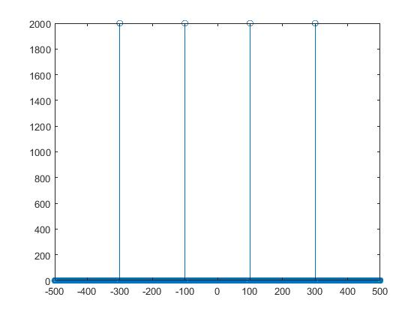

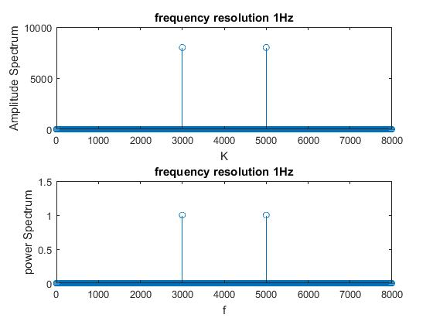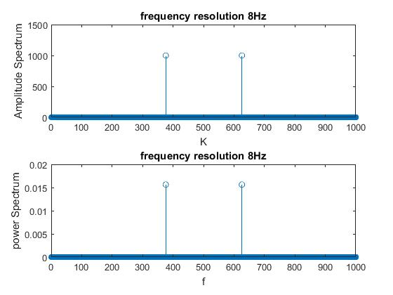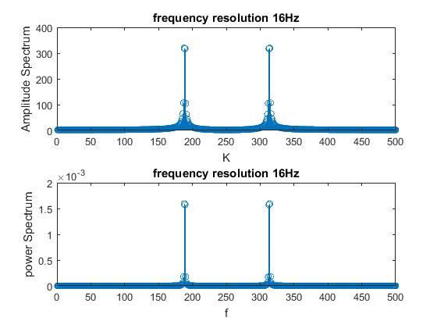

**Result:**

We observe that when we change the frequency resolution the axis shrinks as per the resolution, but the corresponding frequency based on the resolution remains the same.